**MERGE   
(2 year layer processing)**

Open all the properties that are related to this MERGE in PACS

**Screenshot ROLL HISTORY of values for each of the parents and SAVE into folder for this MERGE**(once the merge is processed, all of the values will disappear from parent parcels and will be moved to the child parcel)

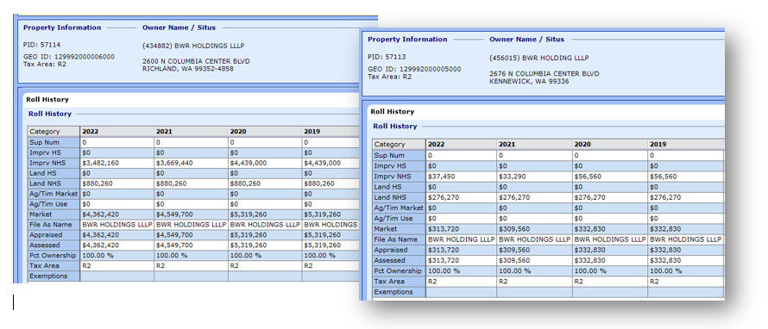  
**Create Balance sheet NOW because once the merge is completed the values will disappear from parent parcels.**

Go to: **Commands >> Merge Property** (this can be done from any of the parent parcel screen)

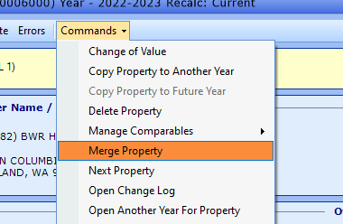

This is what this screen should look like.

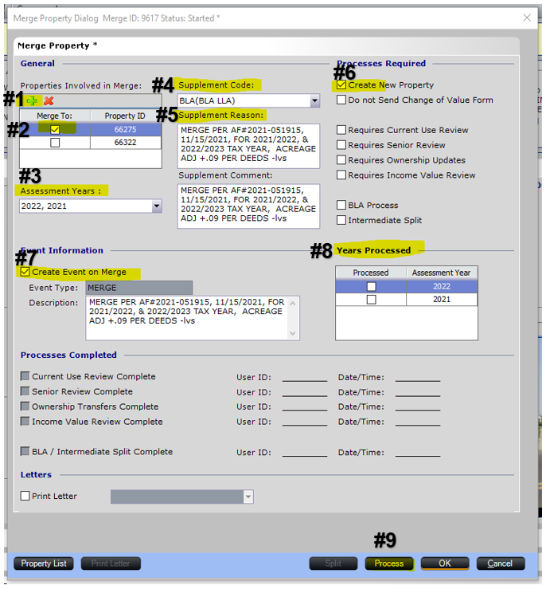

#1. **add** all of the parent properties in this screen  
#2. **click** on the box for your main property – where you want the info to be pulled from. (this has to be marked in order to process this merge)  
#3. **select** all the years for this merge  
#4. **choose** BLA (BLA LLA) – (that’s only if you’re wanting to supplement to process in prev year layer)  
#5. **copy & paste** your event note from prep sheet  
#6. **check** this box – to create new parcel  
#7. **copy and paste** – event note from prep sheet again   
#8. Will show you all the layers for this merge. In order to continue – top layer has to be highlighted as shown above.   
#9. **Click** PROCESS

Click **NEXT & OK**  
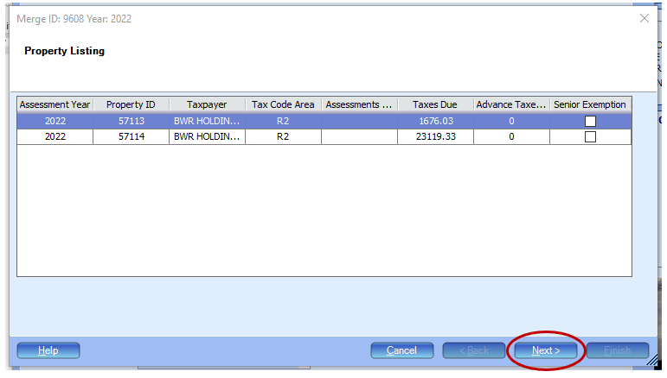

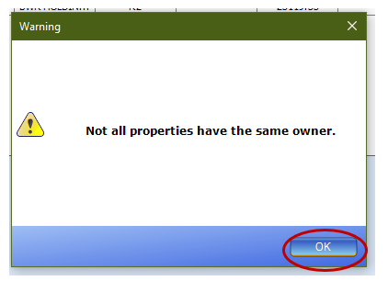

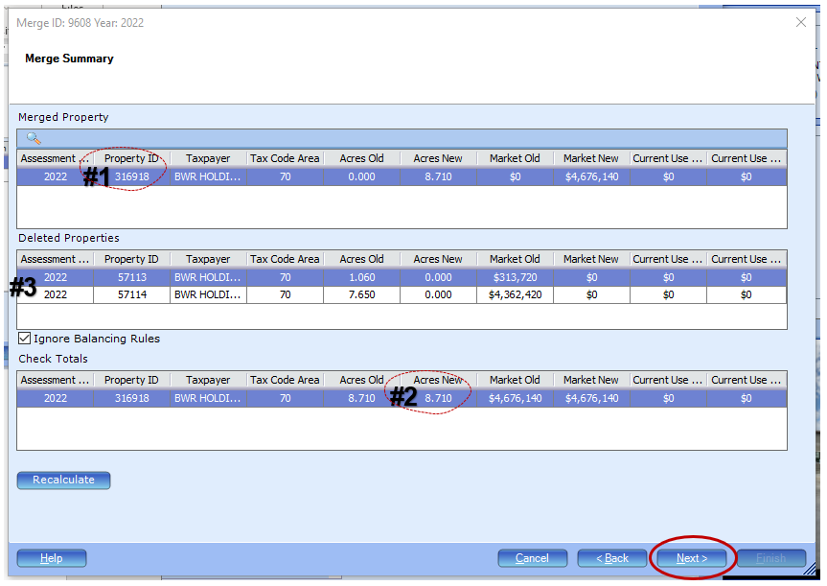  
**#1.** **New PID for Child Parcel**: include this on prep sheet/balance sheet  
**#2.** **New Acreage:** make sure this matches your prep sheet and on your balance sheet.   
**#3.** Double check that all parent parcels are listed here

#4. Click “Next”  
  
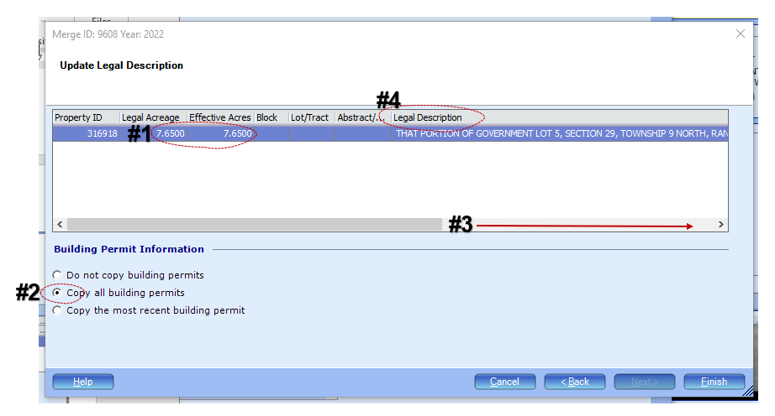  
**#1.** Change acreage in both of these places to new acreage (this number is being pulled from the parent that you clicked on the 1st screen)  
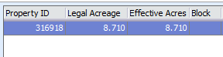  
**#2.** Check “Copy all building permits”

**#3**. Scroll to the parcel column to insert new parcel. Change to a new parcel assigned.  
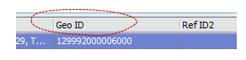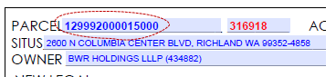

**#4.** We don’t change legal description on this screen, it will give you an ERROR. The legal will be changed on child parcel once its created.

Click: **FINISH**

**This will take you back to the 1st screen.**

**NOW select the next year layer by clicking so it’s highlighted like this.**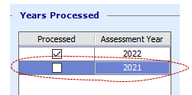

**Click: PROCESS  
NEXT, OK, NEXT**

**And repeat as above:**

Change Acreage, Copy All building permits, the GEO will remain the same, 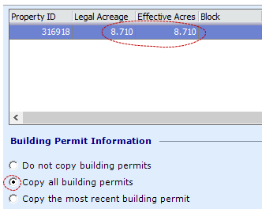

**FINISH – once it finishes processing – the screen will close by itself.**

**NEXT STEP: (if you are not supplementing, skip to Final Step)**

**Go to: Home Screen > Activities**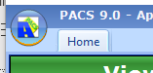

**Click on “Pending Split/Merge”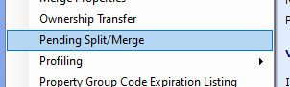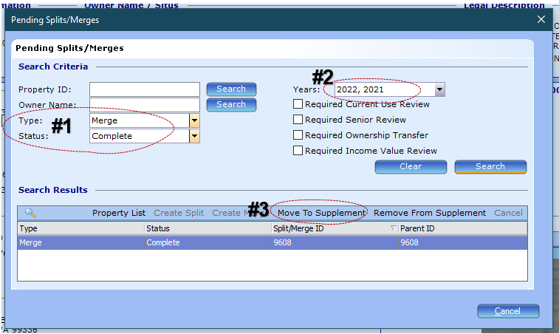 You will need to find your merge in this screen. You can search by Type, Status, or Years.**

**#1. Select:** Merge, Complete

**#2. Important:** Select ALL the years that you processed this MERGE for. This will supplement them for all of the years and delete as well. **SEARCH  
#3** Your Sm00 merge number should show. -> click Move to Supplement

Choose appropriate supplement group > Click ”OK”

This box may pop up after clicking “ok” this is okay. And click “OK”. And X out of the Pending Splits/Merge box.

**FINAL STEP - NOW: finish inputting all the info on the child parcel in ALL year layers. Like BLA or SP**

**\***Replace legal description with new legal description from prep sheet.

**Few Notes: TO KEEP IN MIND.**

Now your parent parcels will show as deleted like this.

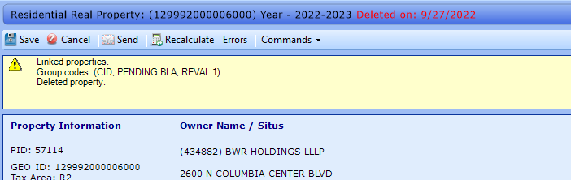

Your Child parcels will show as “pending split or merge” **this will disappear once the next(last) step is done. (If you are not supplementing, this banner will not appear)

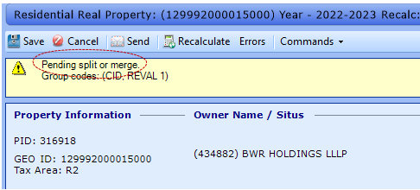

**VALUE TAB:** Click on “Cost Approach” on **BOTH** of the year layers (parcels will not balance if this is not clicked)

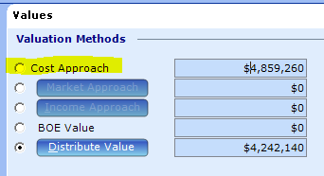 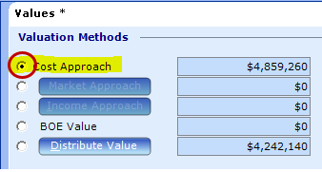

**EVENT NOTE:**  Each property will have its own event note “MERGE”:

Under one property. Link them all together. (and delete extra event note from other properties.)  
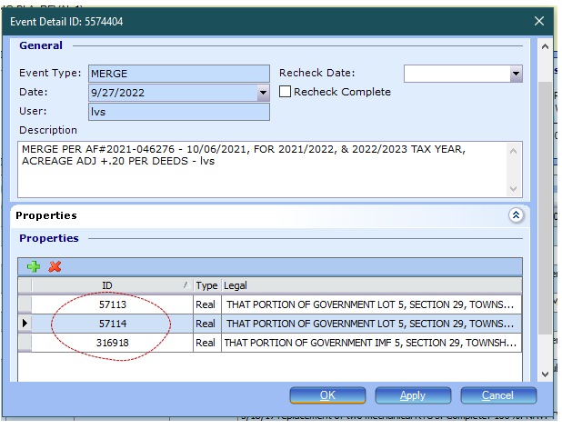  
  
**SM00 NUMBER**: will be found here.

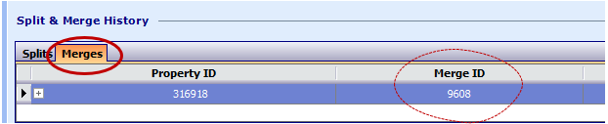

Create a Packet for the appraiser – checklist/worksheet/before and after map/deeds/*legal description – if too long to fit on the worksheet*/values (screenshot of roll history)/letter

**ONCE YOU ARE ALL DONE & PACKET IS BACK FROM APPRAISER**

Go into parent parcels and remove the BLA code and add inactive parcel code.  
Update the checklist.

Add packet to event note.

Update BLA1 and SM00 tracking.

Mail Letter.

And send packet to Audit.